Technical Evaluation Report of the Wi-Fi 6 Hardware Standard as an evolution in the previous standard

**Abstract:**

Mobile devices’ processing capabilities have developed in adherence to Moore's Law, and the speed of information propagation has accelerated consistently. Wi-Fi technology is one way of effectively transferring data. There are six different versions of the Wi-Fi standard, each with its advantages and limitations. It is necessary to critically evaluate the newest standard and the previous one which aim to improve upon the newest generation. In this report, the three essential evaluation criteria are frequency range, transfer speed and coverage of overall performance of Wi-Fi. Using official data from the Wi-Fi Alliance and other journals, this report includes a frequency range diagram to describe the basic components of Wi-Fi. Based on the criteria mentioned above, the evaluation concludes that Wi-Fi 6 is significantly faster than its predecessor under laboratory conditions, although it has a limited coverage of overall performance. Nevertheless, the new Wi-Fi 6 standard may likely replace Wi-Fi 5 in the future.

**Contents:**

**1. Introduction**2

**2. Literature Review**2

2.1 Previous Studies2

2.2 Evaluation Criteria3

**3. Operational Principles** 4

3.1 General Components 4

3.2 Specific Workings Mode of the Wireless Medium5

**4. Critical Evaluation**6

4.1 Evaluation of Frequency Range 6

4.2 Evaluation of Transfer Speed 6

4.3 Evaluation of Coverage Performance7

4.4 Recommendations 7

**5. Conclusion**8

**6. References**9

1. **Introduction**

In recent decades, data exchange has become an indispensable function in smart devices. Wi-Fi standards are implemented in most mobile devices all over the world. Wi-Fi is a wireless standard which uses electromagnetic waves to provide connections [1]. The Wi-Fi Alliance, a non-profit organization which officially certifies Wi-Fi products, has recently released a new Wi-Fi standard in 2018, Wi-Fi 6 [2]. They also renamed the most widely-used standard in the world, IEEE 802.11ac, as ‘Wi-Fi 5’ [3]. The new Wi-Fi 6 standard will be implemented in Wi-Fi routers and smart devices [3]. As a new standard, Wi-Fi 6 could potentially boost download speeds, thereby increasing the speed of information dissemination. Therefore, it is necessary to compare the new standard with the previous one. The new Wi-Fi 6 standard could be adopted in preference to the previous Wi-Fi 5 in the future because the new standard has a wider signal range than the previous one, and the new standard is significantly faster than the Wi-Fi 5, though the Wi-Fi 6 has limited of coverage for overall performance [4]. This report will provide a literature review and a discussion surrounding the technical aspects of Wi-Fi hardware standards. It will then present a critical evaluation of the previous Wi-Fi 5 and the new Wi-Fi 6 based on the criteria of frequency range, transfer speed and coverage of overall performance.

1. **Literature Review**

2.1 Previous Study

The development of Wi-Fi technology improves speed by increasing frequency range and adjusting coverage performance. Sullivan et al. [5] invented the first version of Wi-Fi in 1997. More versions of the Wi-Fi standard were made by the Wi-Fi Alliance [6]. Through the evolution, Wi-Fi 4 achieves 40 MHz’s bandwidth and it supports 2.4 GHz as well as 5 GHz in 2009 [7]-[8]. McFarland [9] proposed a diagram which considers signal model and dual mode to evaluate the transfer speed. Nonetheless, Wi-Fi 5 which was created in 2013 with a maximum net rate of 6.933 Gbps has a frequency range of 5 GHz, instead of 2.4 GHz [10]. Ho et al. [11] suggested that coverage and migration issues could arise as a result of the move from 2.4 GHz to 5 GHz. In 2018, the Wi-Fi Alliance introduced the new Wi-Fi 6 standard. As opposed to Wi-Fi 5, it supports 2.4 GHz as well as 5 GHz [3]. According to [4] stated that the Wi-Fi 6 has a high modulation-level coding scheme. This report will focus on one of the areas that were not covered in previous studies, which is a systematic comparison in the following criteria between Wi-Fi 5 and Wi-Fi 6.

2.2 Evaluation Criteria

Based on the above discussion, the criteria to be evaluated cover frequency range and router transfer speeds, as well as coverage of overall performance. Frequency range will be evaluated first. In complex electromagnetic environments, devices with similar frequencies may interfere with each other in 2.4 GHz [12]-[13]. This report will evaluate both Wi-Fi 5 and Wi-Fi 6’s signal intensity in complex electromagnetic signals. Secondly, Wi-Fi drives the performance and user experience of devices, making it important to ensure that it keeps up with the ever-increasing demands of higher transfer speeds [14]. The high modulation-level coding scheme is an important method to evaluate the transfer speed [15]. Thirdly, the coverage of overall performance directly affects the stability of Wi-Fi. Therefore, evaluating how many devices could access the air at the time is a method to evaluate coverage performance.

1. **Operational Principles**

3.1 General Components

Generally, the four main components of the Wi-Fi based on IEEE 802.11 standard include the station, access points, wireless medium and distribution system [16]. Figure 1 shows how the components within an IEEE 802.11 network are connected. First, station can be understood as devices which make use of wireless network interfaces to transferring information. After that, the station haves an access request from the wireless medium. Then the wireless mediums transmit wireless radio signals [16]. This component directly affects transfer speed because, in a complex network environment, a radio frequency’s physical layer operates within a single band. Therefore, this report will introduce the workings of the wireless medium component specifically. Next an access point allows stations to gain access to a wireless LAN. Finally, a distribution system is used to combine multiple access points [17]. To offer a practical example, one access point is usually insufficient for a large company’s premises. Implementing a distribution system enables a greater connection range than that of a single access point.

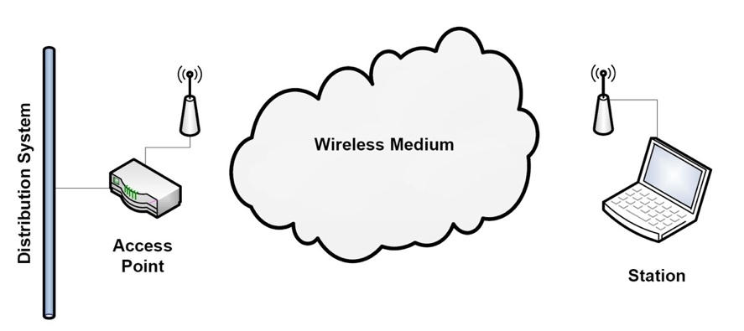

Fig. 1. IEEE 802.11 COMPONENTS [17, pp. 5]

3.2 Specific Workings Mode of the Wireless Medium

In general, when an antenna transmits an RF signal, the signal’s frequencies operate within a specific band, as shown in Figure 2. The wireless medium consists of two frequencies bands, from the 2 GHz to the 4 GHz and 5 GHz to the 8 GHz. For the frequency of 2.4 GHz, it provides a wider signal range because it is more capable of crossing obstacles than 5 GHz [18]. In addition, 2.4 GHz is also subdivided into 14 channels, equaling a total bandwidth of 84 MHz [19]. Each adjacent channel consists of an intersection of frequencies, and it is the reason for the direct interference of similar frequencies [13]. For example, 2.422 GHz and 2.427 GHz have the 5 MHz frequency coverage [19]. Therefore, the influence of intersection interference of signal frequency will be assessed in the evaluation part.

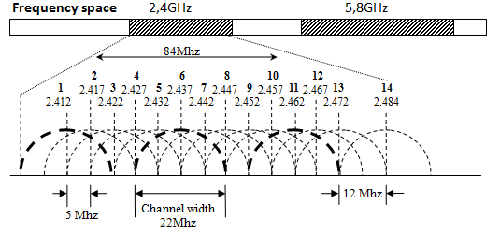

Fig. 2. IEEE 802.11 CHANNELS AND FREQUENCES [19]

**4. Critical Evaluation**

4.1 Evaluation of Frequency Range

Wi-Fi 6 supports both 2.4 GHz and 5 GHz, while the Wi-Fi 5 only supports 5 GHz, which means in the complex electromagnetic signals and complex environment, Wi-Fi 6 supports a wider frequency range and it has better signal strength under most conditions than Wi-Fi 5 [3]-[20]. Devices that use the 5 GHz are generally able to avoid interference coming from numerous other devices. Within a 2.4 GHz Wi-Fi environment, for example, Bluetooth technology can interfere with Wi-Fi signals, leading to net speed loss [12]. However, 5 GHz reduces interference between overlapping signals which could result in delays within complex environments (such as schools) because it is less affected by different frequencies [17]. Based on the above viewpoints, Wi-Fi 6 has more adaptable scenes than Wi-Fi 5 in the complex environment.

4.2 Evaluation of Transfer Speed

While Wi-Fi 6 could probably consume more energy, the transfer speed of Wi-Fi 5 is much lower than Wi-Fi 6 under the same signal intensity. Because Wi-Fi 6 supports a high modulation-level coding scheme in 1024QAM, however, Wi-Fi 5 only supports maximum 256QAM [15]. For example, On the highway, cars travel at the same speed, and the number of new versions of cars is more than twice than the previous one. Based on this, Wi-Fi 6 offers faster transfer speeds than that of Wi-Fi 5.

4.3 Evaluation of Coverage Performance

In the criteria of coverage performance, Wi-Fi 6 has limitation of accessing the air at the time [4]. This is the weakness of Wi-Fi 6 relative to Wi-Fi 5. For example, if multiple users access a resource at the same time in Wi-Fi 6, coverage of overall performance will be sacrificed. The end result is reduced access speed. Therefore, this forced compromise undermines the coverage performance of Wi-Fi 6.

4.4 Recommendations

Based on the above evaluation, Wi-Fi 6 has two key weakness in terms of its coverage performance and greater power demands. It is recommended that coverage performance should be solved so that multiple users can access a media at the same time without any impact. In this way, transmission efficiency could be improved in the future. Power management systems need to be redesigned to support the new Wi-Fi 6 standard. To help router manufacturers improve their products, the Wi-Fi Alliance should provide a more effective energy management system. For example, calculations can be done to ensure that newly-designed devices do not overheat as a result of excessively high transfer speeds.

**5. Conclusion:**

The purpose of this report was to critically evaluate the new Wi-Fi 6 and the previous Wi-Fi 5 based on three separate criteria: frequency range, transfer speed and coverage performance. It was found that Wi-Fi 5 is in a disadvantage compared with the new in the frequency range and transfer speed. However, Wi-Fi 6 has compromised in coverage performance. In terms of frequency range, Wi-Fi 5 only uses 5 GHz, while Wi-Fi 6 uses both 2.4 GHz and 5 GHz. Wi-Fi 6, therefore, offers more versatility to the user, which is a significant improvement upon the previous generation of Wi-Fi standard. In terms of transfer speed, while Wi-Fi 6 may consume more energy, it is also significantly faster than the previous generation under laboratory conditions, but these results are still unpredictable under complex, real-world electromagnetic conditions. In terms of coverage performance, Wi-Fi 6 only allows one device access the air at the time. In the future, issues around power management and coverage performance of routers should be addressed.

**6. References:**

[1] V. Beal. (N.D.). *What is Wi-Fi (Wireless)? Webopedia Definition* [Online]. Available: https://www.webopedia.com/TERM/W/Wi_Fi.html

[2] J. Kastrenakes. (2018, Oct. 3). *Wi-Fi now has version numbers, and Wi-Fi 6 comes out next year* [Online]. Available:

<https://www.theverge.com/2018/10/3/17926212/wifi-6-version-numbers-announced>

[3] (2018, Oct. 3). *Wi-Fi Alliance® introduces Wi-Fi 6* [Online]. Available:

<https://www.wi-fi.org/news-events/newsroom/wi-fi-alliance-introduces-wi-fi-6>

[4] M. S. Afaqui *et al*.,"IEEE 802.11 ax: Challenges and requirements for future high

efficiency WiFi," *IEEE Wireless Communications.*,vol. 24, no. 3, pp. 130-137, 2017.

[5]J. O. Sullivan. (2012). *EPO - High-speed wireless networking* [Online]. Available: <http://documents.epo.org/projects/babylon/eponet.nsf/0/E9DF20071F8F0733C12579F300521F60/$File/osullivan_en.pdf>

[6] (N.D.). *Who We Are | Wi-Fi Alliance* [Online]. Available:

<https://www.wi-fi.org/who-we-are>

[7] *802.11n-2009 - IEEE Standard for Information technology-- Local and metropolitan area networks-- Specific requirements-- Part 11: Wireless LAN Medium Access Control (MAC) and Physical Layer (PHY) Specifications Amendment 5: Enhancements for Higher Throughput,* IEEE Standard, 2009.

[8] M. Gast, *802.11n : a survival guide*. Sebastopol, CA: O'Reilly, 2012.

[9] B. McFarland and A. Tabatabaei, “A 2.4 & 5 GHz dual band 802.11 WLAN supporting data rates to 108 Mb/s,” *IEEE Conference Publication*. [Online]. Oct. 2002. Available: <https://ieeexplore.ieee.org/abstract/document/1049018>

[10] R. P. F. Hoefel, "Ieee 802.11 ac: A performance assessment of single-user transmit

beamforming and multi-user mimo transceiver architectures," in *ISWCS 2013, The Tenth*

*International Symposium on Wireless Communication Systems*. Ilmenau: VDE, 2013, pp. 1-5.

[11] M. J. Ho *et al.*, “RF challenges for 2.4 and 5 GHz WLAN deployment and design,”

*IEEE Wireless Communications and Networking Conference* Record., vol. 2, pp. 783-788, March. 2002.

[12] A. SÂRbu, M. SÂRbu, and C. ȘUmĂLan, "NON WI-FI DEVICES INTERFERENCE TESTING IN A 2.4 GHZ WI-FI HOME," *Revista Academiei Fortelor Terestre*.,vol. 23, no. 2, pp. 143-150, 2018.

[13] I. Dolińska *et al*.,"Interference comparison in Wi-Fi 2.4 GHz and 5 GHz bands," in

*2017 International Conference on Information and Digital Technologies (IDT)*. Zilina, Slovakia: IEEE, 2017, pp. 106-112.

[14] L. Verma and M. Fakharzadeh, “Wifi on steroids: 802.11AC and 802.11AD,” *IEEE Journals & Magazine.* [Online]. Available: <https://ieeexplore.ieee.org/abstract/document/6704471>

[15] (2018). *IEEE 802.11ax Technology Introduction White Paper* [Online]. Available: https://scdn.rohde-schwarz.com/ur/pws/dl_downloads/dl_application/application_notes/1ma222/1MA222_1e_IEEE80211ax.pdf

[16] M. Gast, “Overview of 802.11 Networks," in *802.11 wireless networks: the definitive guide*, M. Loukides et al., Eds. California: O'Reilly Media, 2005, pp. 12-28.

[17] G. Castignani, “Adaptive discovery mechanism for wireless environments,” in *IFIP International Federation for Information Processing* (No. 1), 2010, pp. 5-20.

[18] (N.D.). *What is the difference between 2.4 GHz and 5 GHz wireless frequencies?* [Online]. Available: https://kb.netgear.com/29396/What-is-the-difference-between-2-4-GHz-and-5GHz

[19] (2013, Dec. 31). Testwiki/MikroTik Wireless Networks [Online]. Available:

<https://wiki.mikrotik.com/wiki/Testwiki/MikroTik_Wireless_Networks>

[20] (2018). *802.11ac: The fifth generation of Wi-Fi technical white paper* [Online]. Available: https://www.cisco.com/c/dam/en/us/products/collateral/wireless/aironet-3600-series/white-paper-c11-7